**Regional Sales Analysis CEP**

1. Created 2 parameters below to list all regions in them and allow region selection.

Outputs:

1.1 Primary Region Parameter

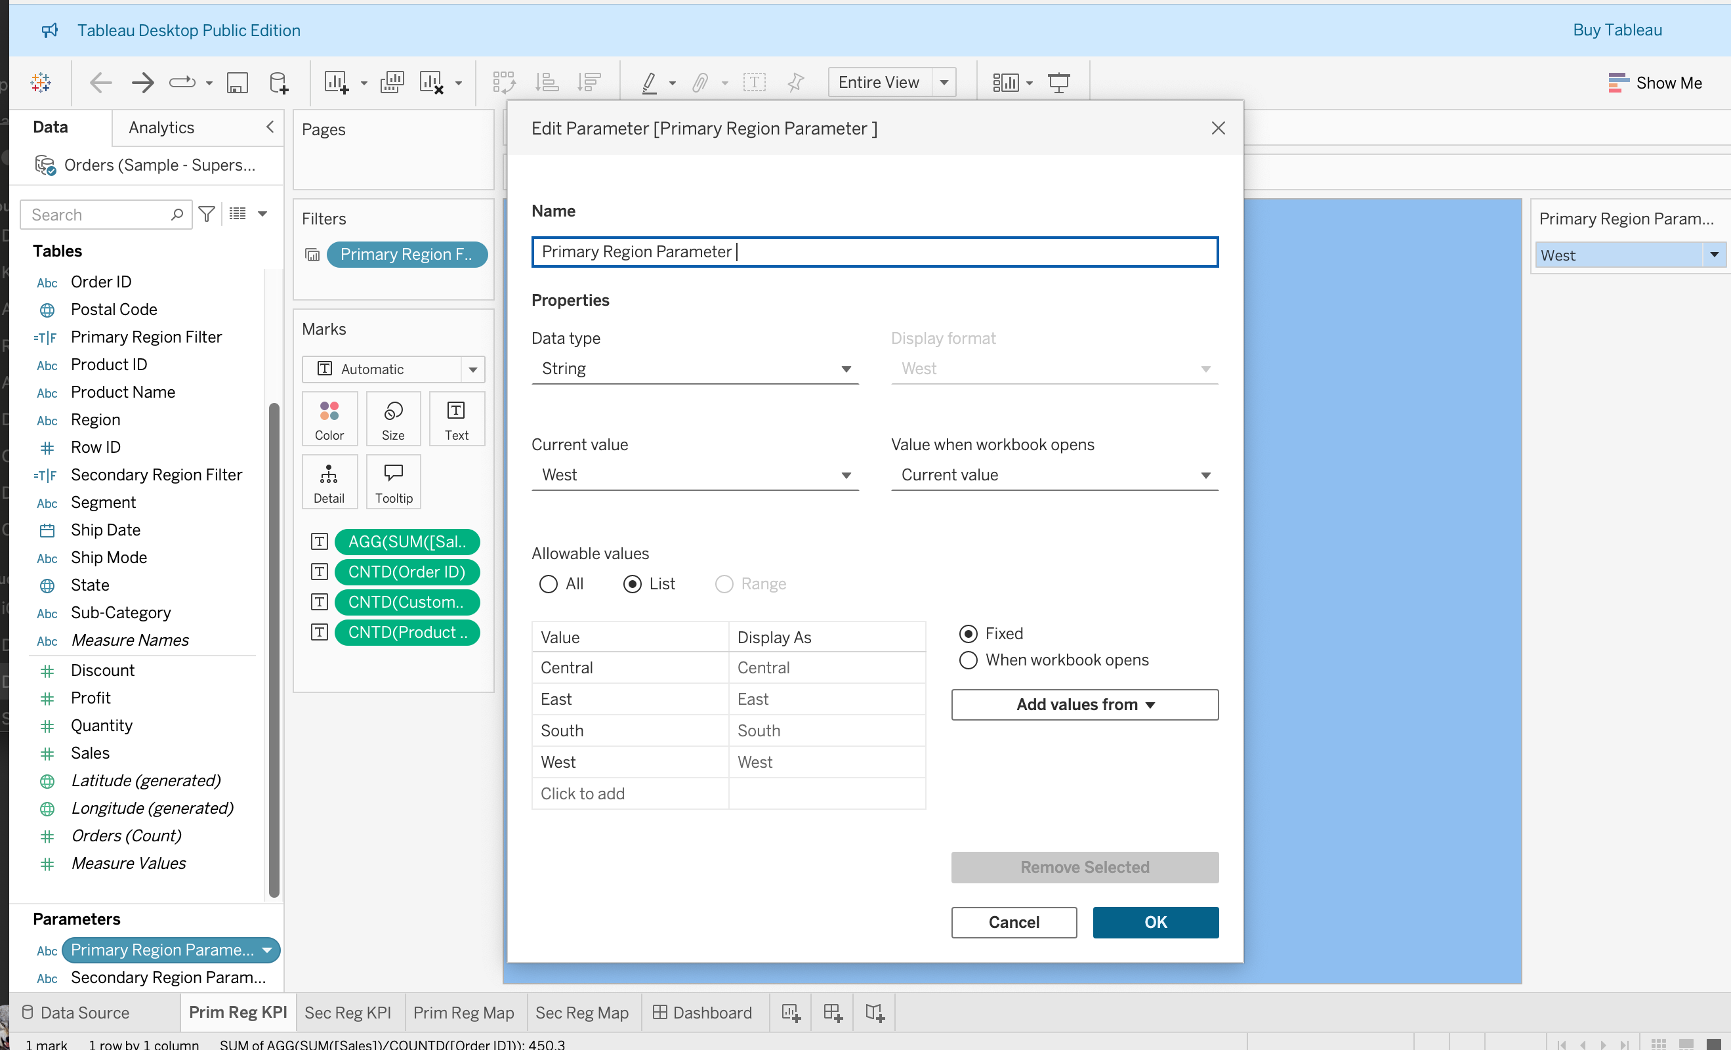

1.2 Secondary Region Parameter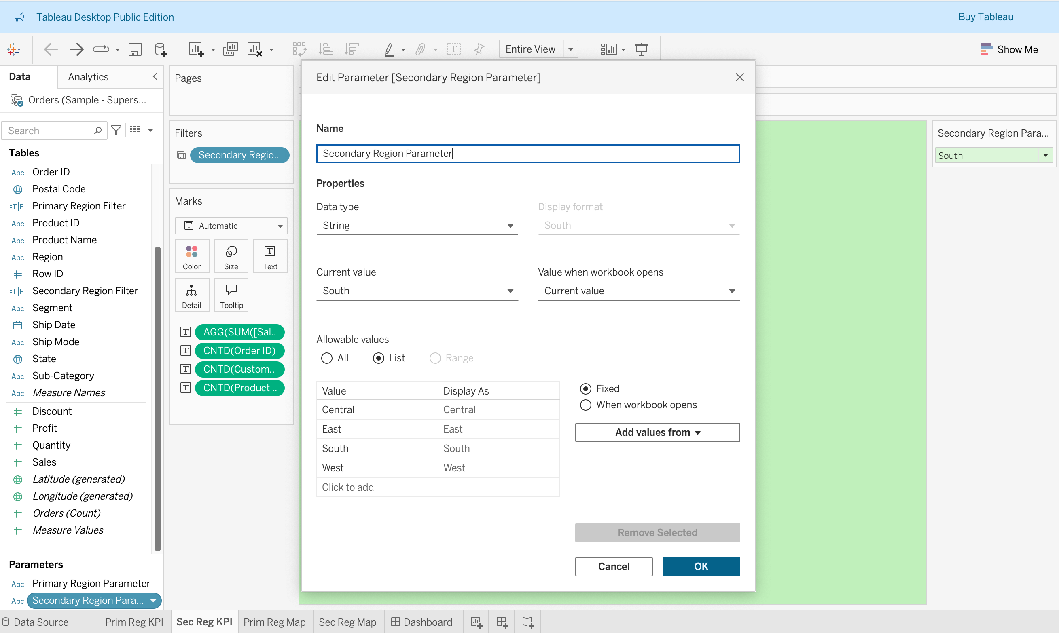

1. Created 2 calculated fields to filter the data based on the selected regions

Outputs:

* 1. Created a Calculated Field called Primary Region Filter and another called Secondary Region Filter and put the formula Region = Primary Region Parameter as displayed below

2.1.1 Primary Region Calculated Field

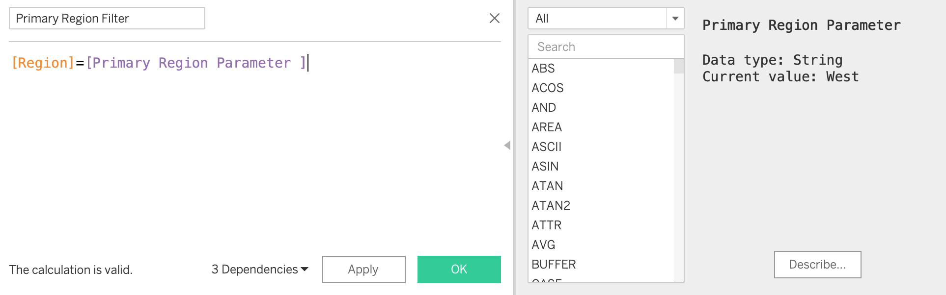

2.1.2 Secondary Region Calculated Field

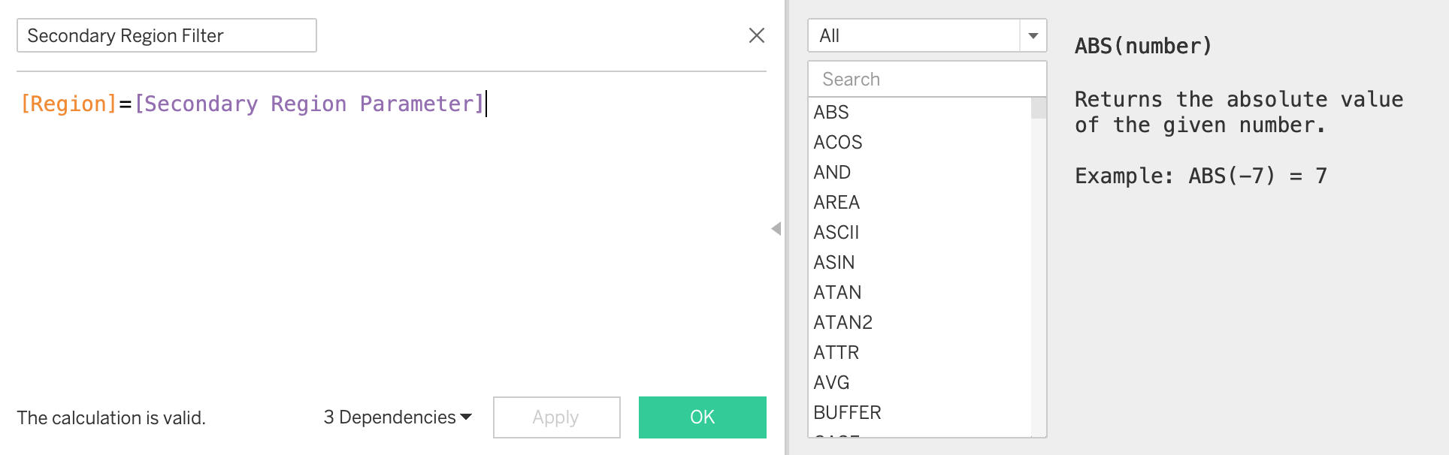

2.3 Displayed the total sales across all regions using separate worksheets for the primary and secondary regions -> Dragged the Sales field to the Text option in the Marks Card and did formatting. (Region-wise total sales selection is also done in section 3 below).

2.3.1 Primary Region Total Sales Across All Regions

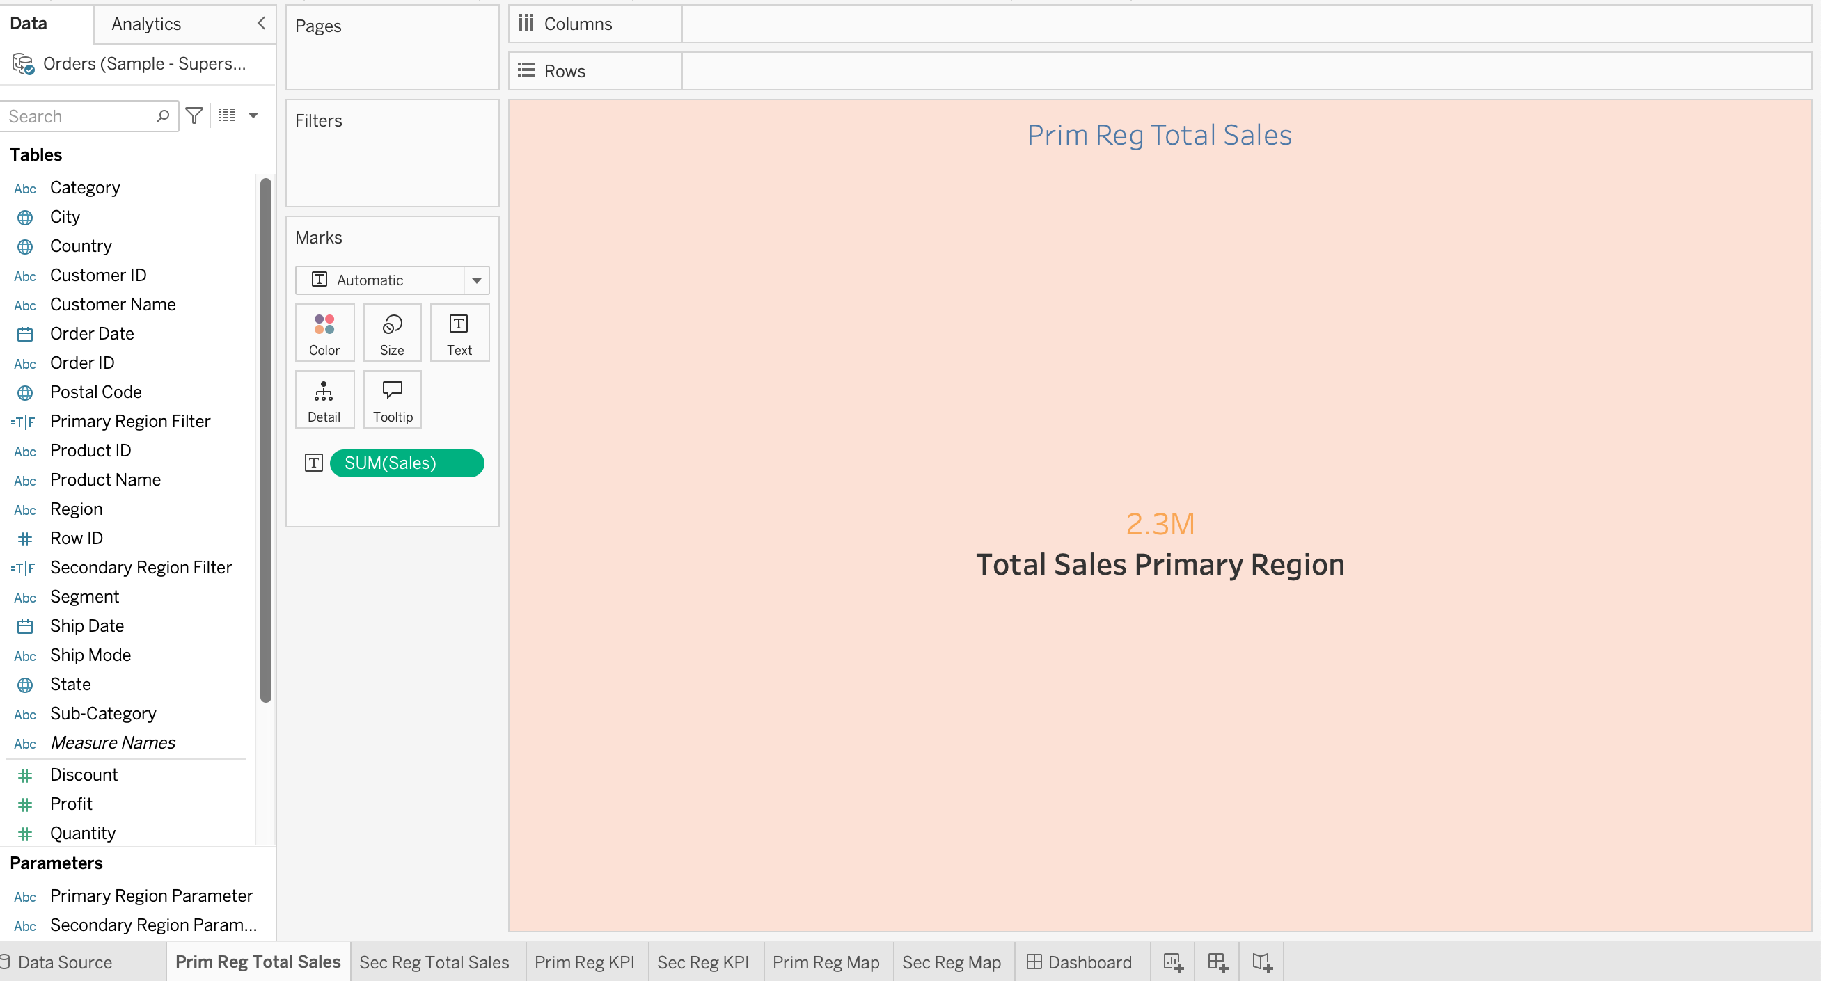

2.3.2 Secondary Region Total Sales Across All Regions

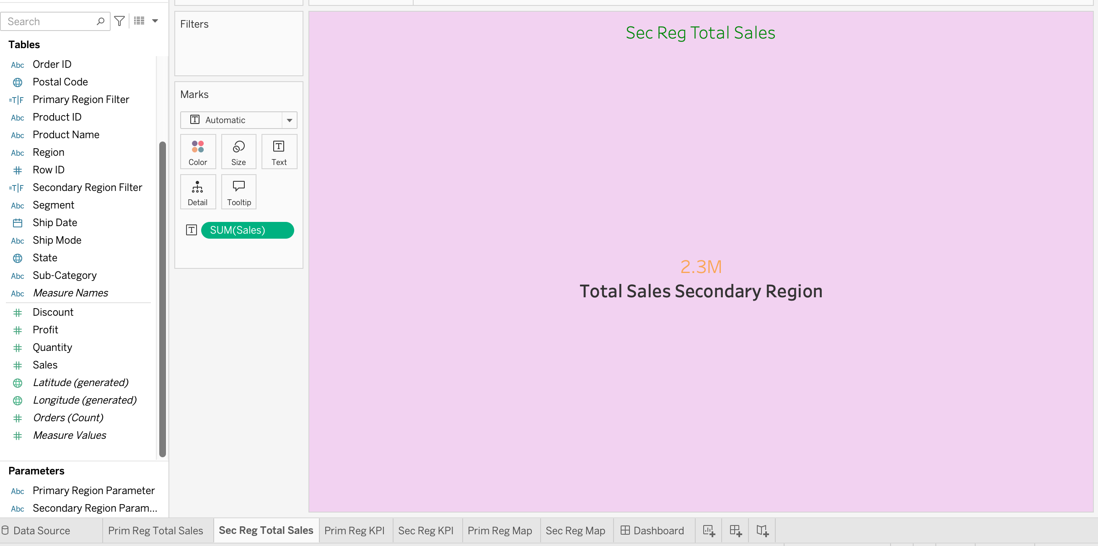

1. Created 1 worksheet for the Primary Region KPIs and 1 worksheet for Secondary Region KPIs showing in both worksheets:

* The total sales for each region within the primary and secondary region worksheets
* The average sales per order for both the primary and secondary regions using the formula: SUM([Sales])/COUNTD([Order ID]) in the Marks Card
* A count of the total number of unique orders in each region
* The number of unique customers in each region
* The number of distinct products sold in each region

Outputs:

3.1 Marks Card for both Primary and Secondary Region KPI Sheets

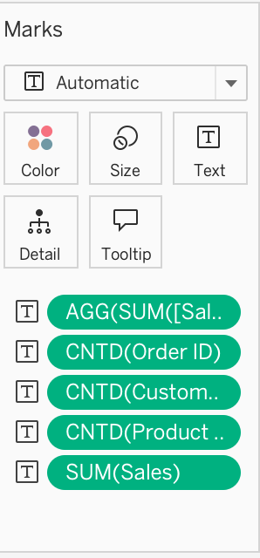

* 1. Primary Region KPIs

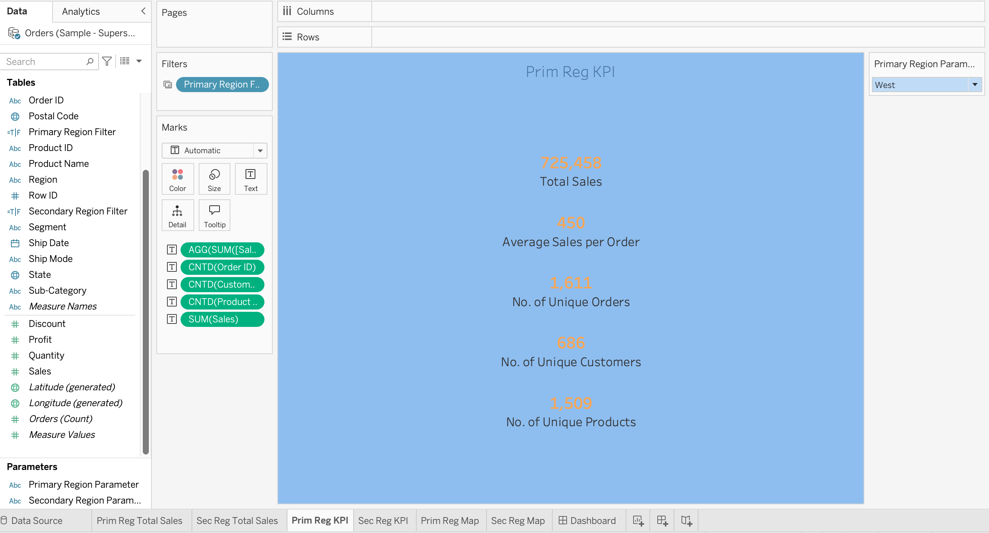

* 1. Secondary Region KPIs

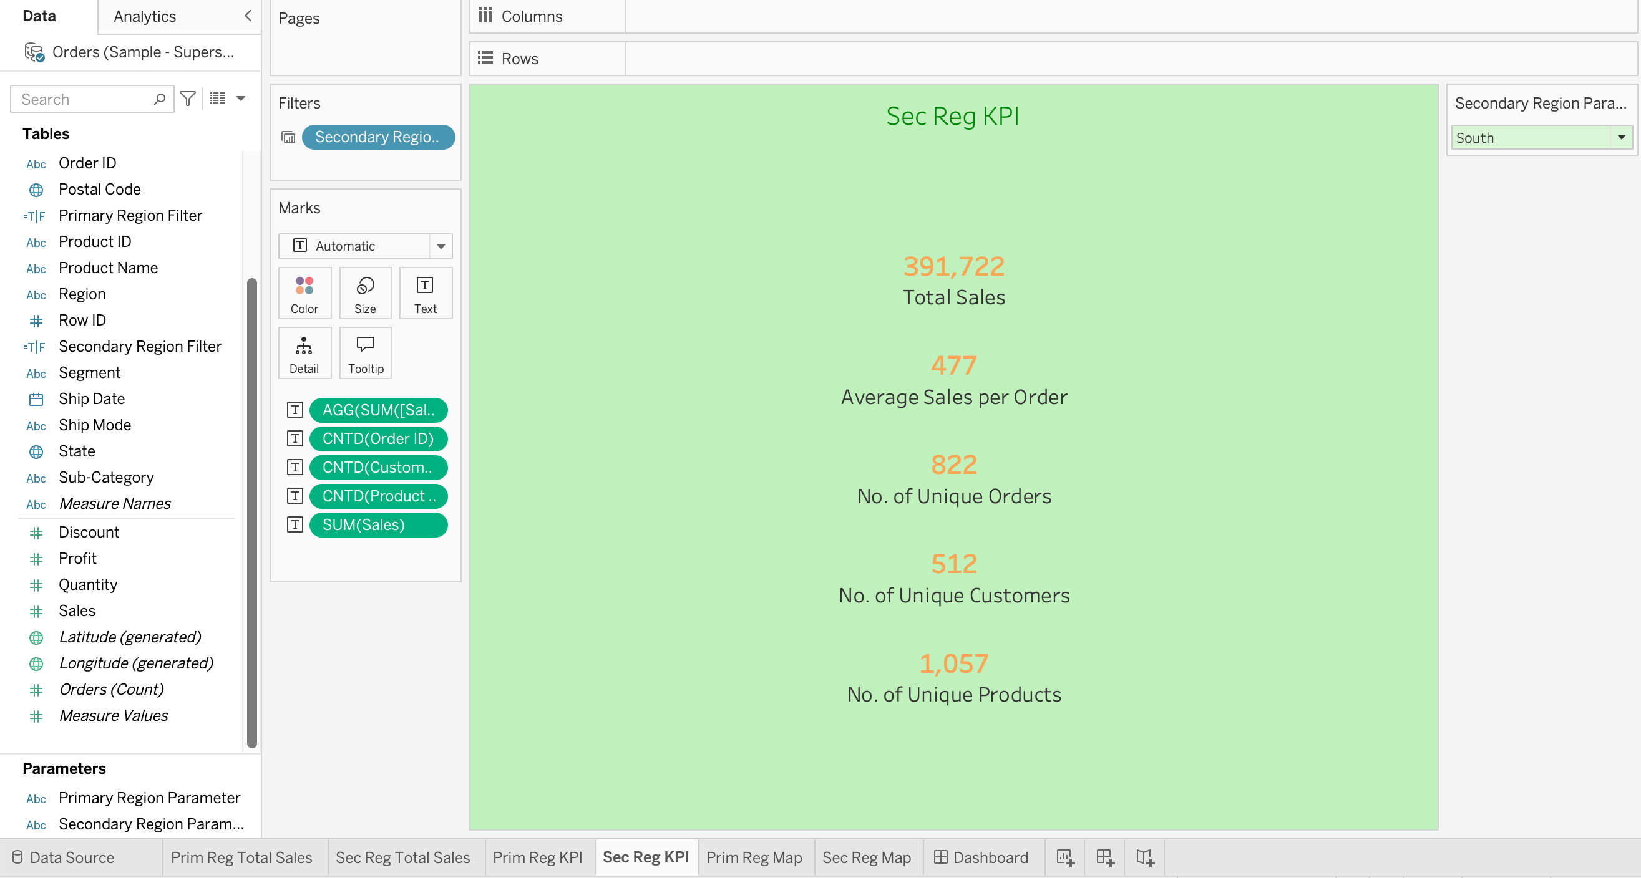

1. Dragged the Primary Region Calculated Field to the Filter Card and selected True to enable the Primary Region Parameter to change the data according to different region selections

Outputs:

4.1 Primary Region Filter

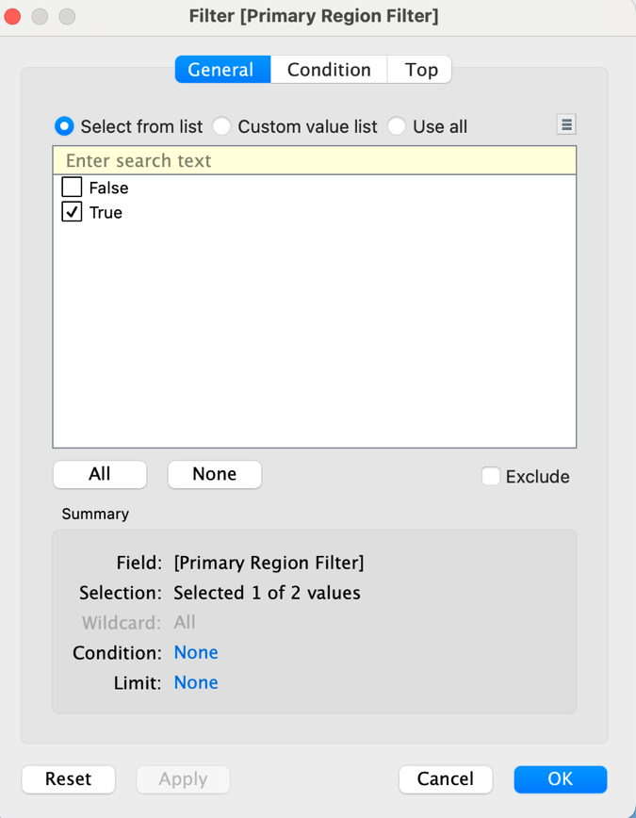

4.2 Primary Region Selection East (Different to the Primary Region West filter selection displayed in step 3.2 above)

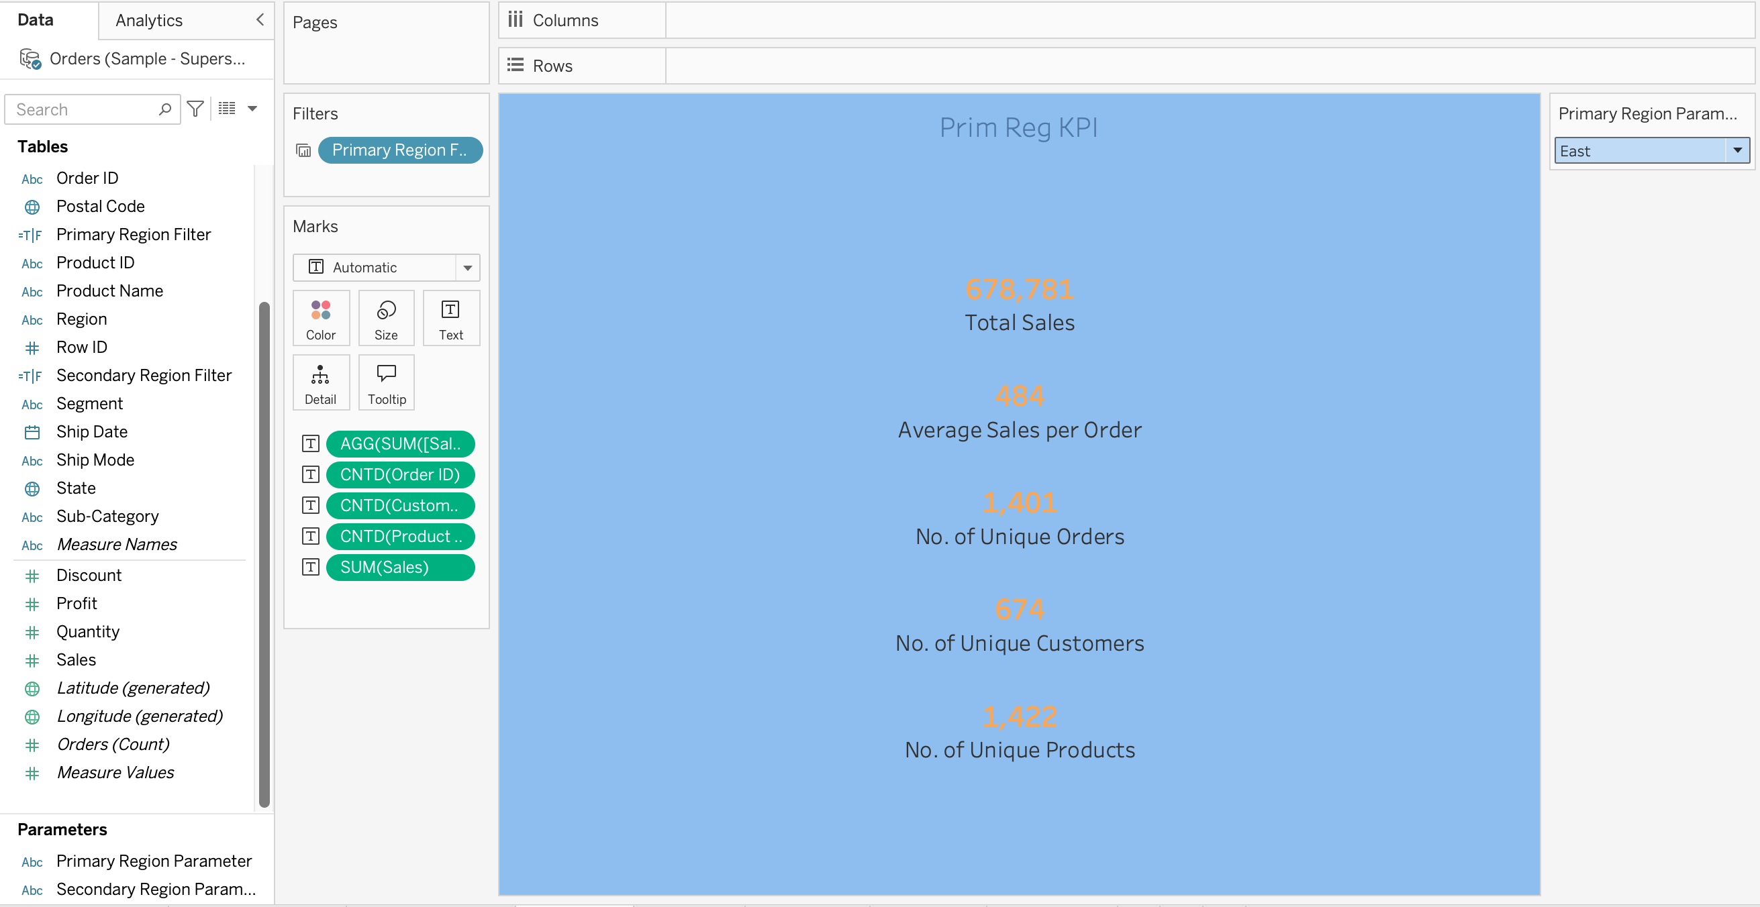

4.4 Repeated steps 4 - 4.1 for the Secondary Region Calculated Field

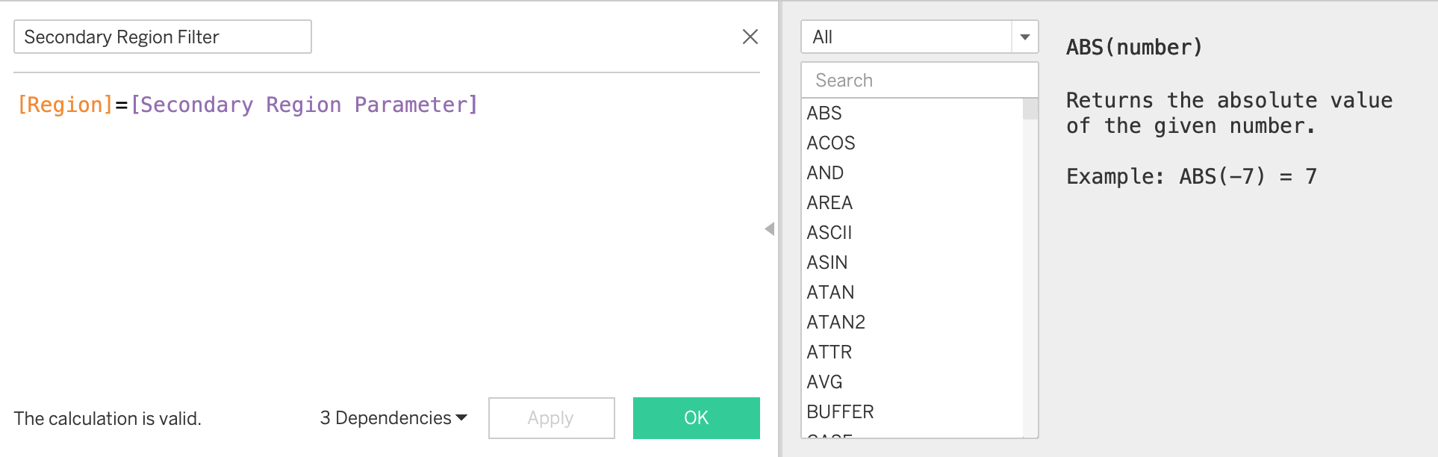

4.6 Secondary Region Filter Selection Central (Different to the Secondary Region South filter selection displayed in step 3.3 above)

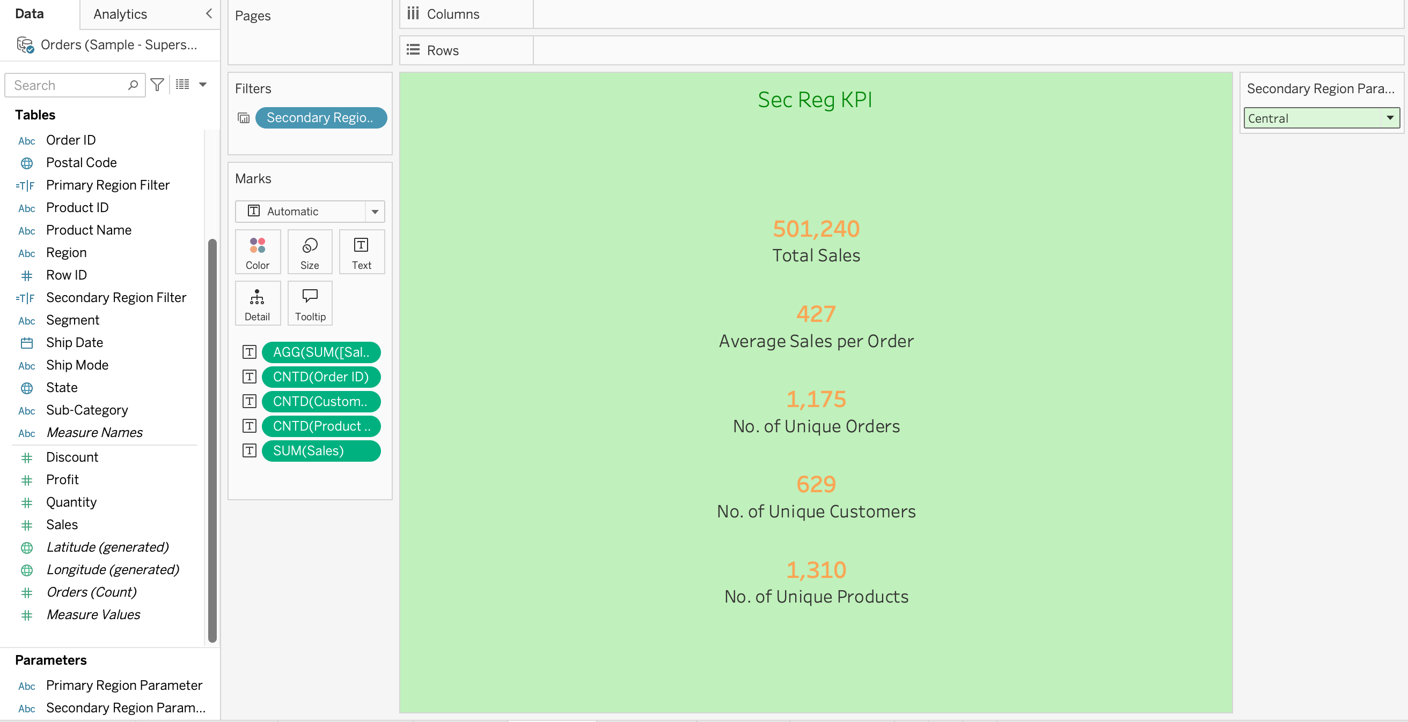

5. Comparative Analysis:

• Combined the individual worksheets into a single dashboard and used containers to partition the dashboard into sections for the primary and secondary regions.

• Added parameter controls to allow users to select different regions and dynamically update the visualisations

• Added an additional Primary and Secondary Region Map to the Dashboard and applied the Region filters to them to enable dynamic selection with the region parameters

Outputs:

5.1 Regional Sales Analysis Dashboard with containers to separate regions and region-specific parameters for dynamic updates

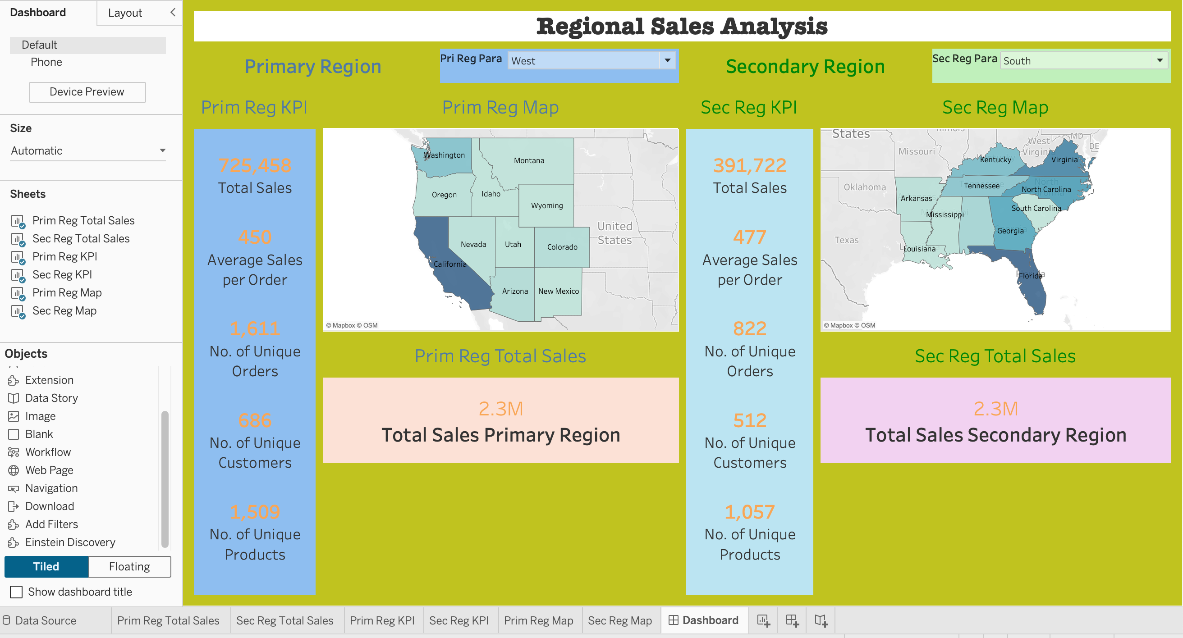

5.2 Applied filter to the Map sheets for dynamic selection on Dashboard

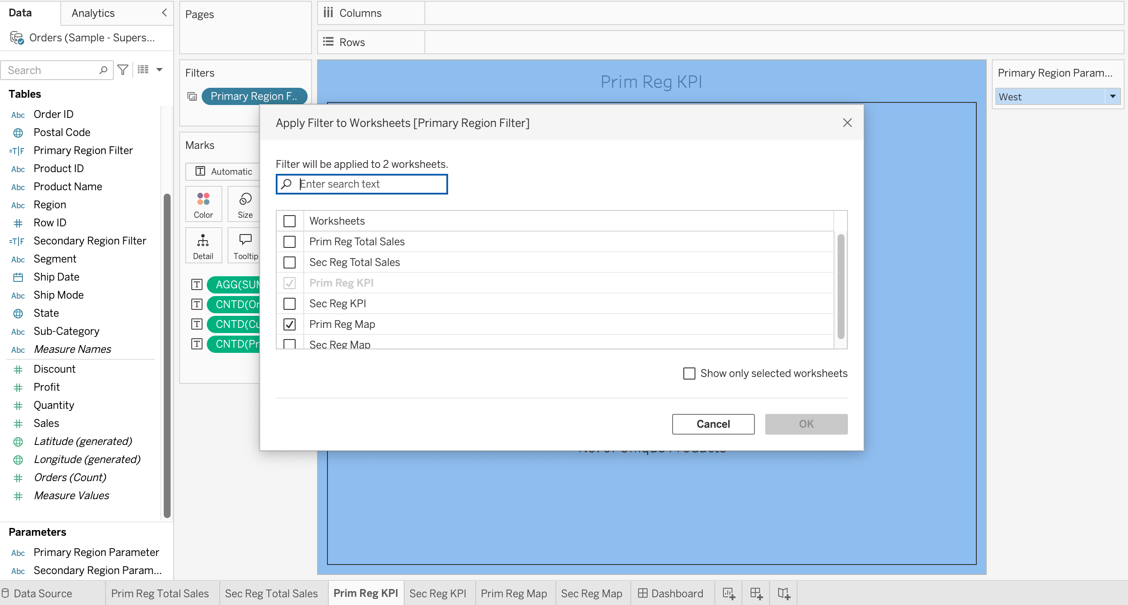

5.3 Created a Primary Region Map as an additional visualisation on the Dashboard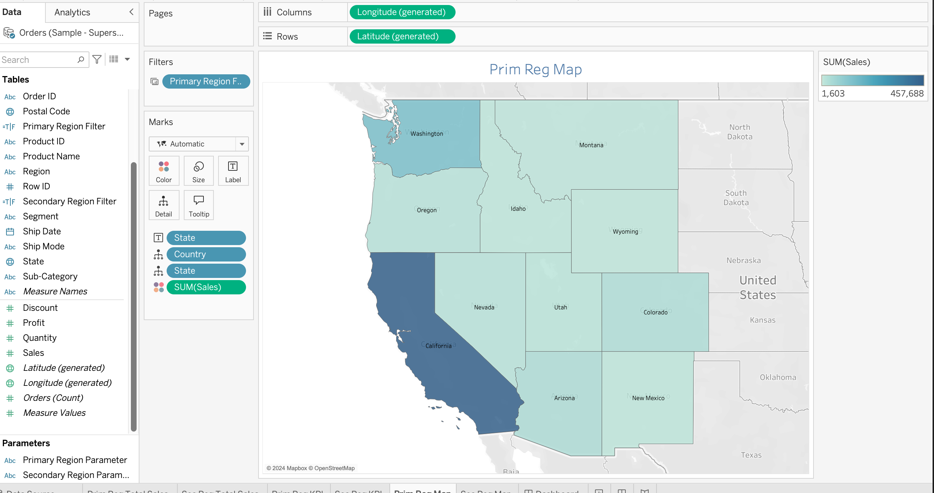

5.4 Created a Secondary Region Map as an additional visualisation on the Dashboard

